EXPERIMENT-5

ROLL NO:230701320 NAME:Sivaruhith S

Conduct task analysis for an app (e.g., online shopping) and document user flows. Create corresponding wireframes
using Lucidchart:
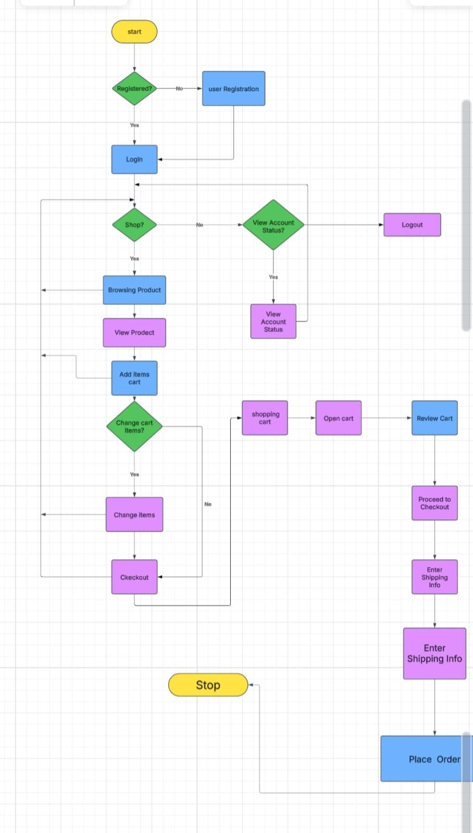
AIM: To understand and document the steps a user takes to complete the main tasks within an online shopping app.

Task Analysis and User Flow for the Documentation Process Task Analysis
The flowchart represents the user journey in an e-commerce system, covering registration, shopping, cart management, and order placement. The key tasks involved are:

User Registration & Login
  - If a user is not registered, they must complete registration.
  - If registered, they log in to proceed further.

Shopping Process
  - Users decide whether to shop or check their account status.
  - If shopping, they browse products, view product details, and add items to the cart.

Cart Management
  - Users can review their cart and make changes if necessary.
  - Proceed to checkout once satisfied with cart contents.

Checkout Process
  - Open the shopping cart and review items.
  - Proceed to checkout by entering shipping information.
  - Confirm the order by placing it.

Account Management & Logout
  - If users choose not to shop, they can check their account status.
  - Logout option is available if users do not wish to continue.

User Flow
- Entry Point
  - The user starts at the "Start" node.
  - If not registered → Redirect to Registration.
  - If registered → Login.

Shopping Experience
  - After login, the user chooses between shopping or checking account details.
  - If shopping, the user browses products, views details, and adds items to the cart.
  - Users can modify cart items before proceeding to checkout.

Cart & Checkout Process

  - Users review their cart, proceed to checkout, enter shipping details, and place the order.
  - The process concludes at the "Stop" node after order placement.

Alternative Flow
  - If users decide not to shop, they can check account details.
  - Logout option is available at any point.

Task Analysis and User Flow – Detailed Steps
It provides a step-by-step breakdown of the user journey in an e-commerce system, covering user actions from registration to order placement.

Entry Point (Start)
  - The user begins at the Start node.
  - A decision is made: Is the user registered?
    - If No → Redirect to User Registration.
    - If Yes → Proceed to Login.

User Registration (If Not Registered)
  - The user is directed to the registration form.
  - The user provides:
    - Name
    - Email
    - Phone Number
    - Password
  - After submission, the system verifies details.
  - If valid → Registration successful, user proceeds to Login.
  - If invalid → Show error message & request corrections.

User Login
  - The user enters:
    - Email/Username
    - Password

  - If credentials are correct → Access is granted.
  - If incorrect → Show error message & request re-entry.

Shopping Decision
  - The system asks: Does the user want to shop?
    - If Yes → Go to Browsing Products.
    - If No → Go to View Account Status.

Browsing Products & Adding Items
  - The user browses products.
  - The user clicks on a product to view details.
  - Options:

Add item to cart.
    - Return to browsing.
  - If an item is added, the system updates the Shopping Cart.

Shopping Cart Management
  - The system asks: Change cart items?
    - If Yes → User can:
      - Remove items.

Change quantity.
      - Modify selections.
    - If No → Proceed to Checkout.

Checkout Process
  - The user navigates to the Shopping Cart.
  - The user opens the cart and reviews selected items.
  - The user proceeds to checkout.

Entering Shipping Information
  - The system prompts the user for:

    - Full Name
    - Address
    - City & ZIP Code
    - Phone Number
    - Payment Method
  - The user submits shipping info.
  - If valid → Proceed to Place Order.
  - If invalid → Show error message & request corrections.

Placing the Order
  - The system confirms the order summary.
  - The user places the order.
  - The system processes payment & generates a confirmation message.

Viewing Account Status (If Not Shopping)
  - The user chooses View Account Status.
  - The system displays:
    - Order history
    - Account details
    - Saved addresses & payment methods
  - The user can log out or return to shopping.

Logout & End
  - The user logs out.
  - The system ends the session.
  - The process stops.

